**Film Noir**

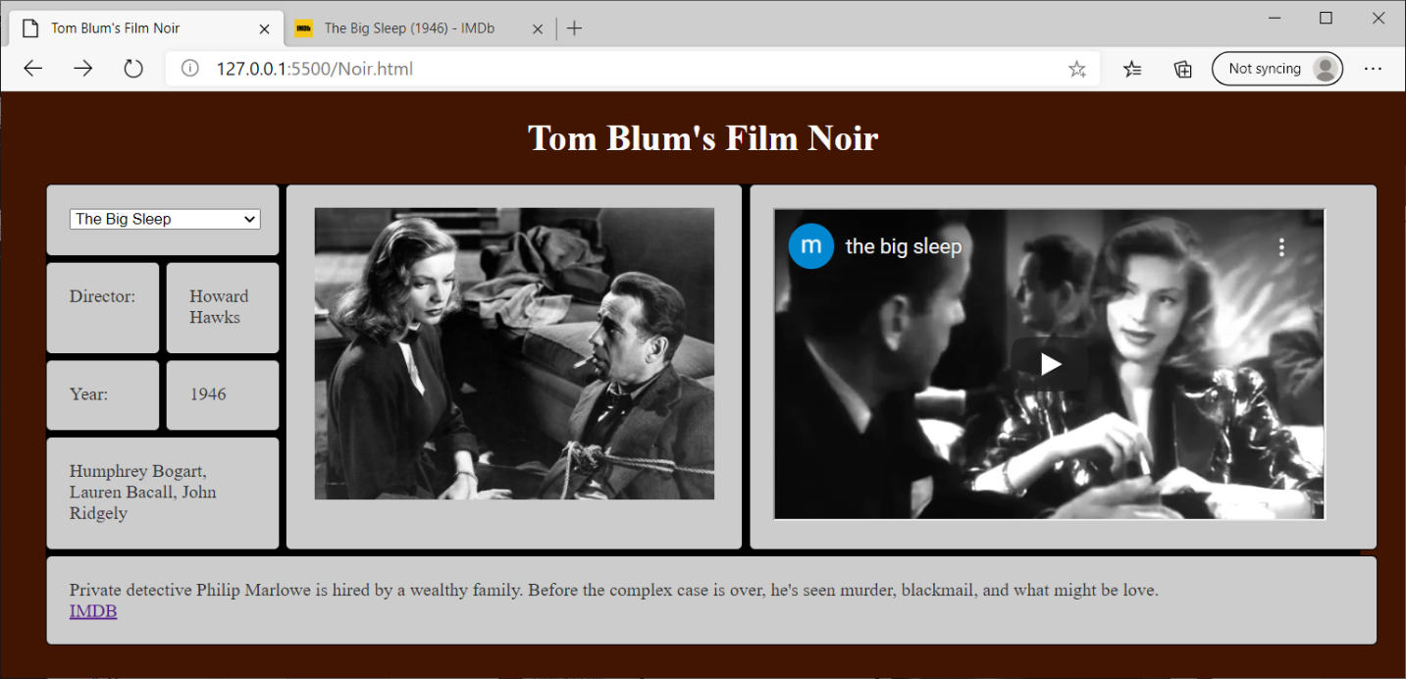

1. Use the headstart **Noir.html**. Add a title John Smith’s Film Noir (with John Smith replaced by your name).
2. Add an HTML comment with your name.
3. Your HTML elements with ids cannot have default/meaningless ids such as Button1. They also cannot refer to some previous subject – such as books, movies, etc.
4. Make the page’s background color and (font) color anything other than the default values.
5. Put a header with John Smith’s Film Noir (with John Smith replaced by your name) at the top of the page.
6. Place a JavaScript comment with your name at the top of the script area.
7. Use fetch to read the file noir.json. And use this information to establish a global object containing all of the film noir data.
8. Add a drop-down select and use JavaScript code to populate it with options showing the film titles.
9. Add an image with a width of 350px to display the movie still.
10. Add an iframe of height 270px and width 480px to embed the youtube film clip.
11. Put two containers in the bottom div that spans four columns. The first will display the film’s description and the second will have a link to the IMBD page about that movie. Use target="_blank" so that the hyperlink opens a new tab .
12. Fetch the json file and populate the drop-down select with film titles.
13. When the user changes the title in drop-down select, that film’s director, year, stars, and description should be displayed.
14. In addition, that film’s still should be displayed and a youtube clip from that film should be displayed.
15. The IMDB link at the end of the description should be updated to the selected movie.
16. A random film should be selected to be displayed at the start.